## 1. Project Overview

This project is an *Excel-based Sales and Profit Analysis Dashboard* designed to analyze business performance using sales transaction data.

The project analyzes:

* Countries / Markets
* Products
* Units Sold
* Revenue
* Cost
* Profit
* Sales Date
* Monthly performance

The main objective is to transform raw sales data into meaningful business insights using *Excel formulas, PivotTables, monthly analysis, and a dashboard*.

---

## 2. Project Objectives

The main objectives of this project are:

1. Analyze total sales revenue.
2. Calculate total business costs.
3. Analyze total profit.
4. Measure the number of units sold.
5. Analyze profit by month.
6. Analyze units sold by month.
7. Compare business performance across markets.
8. Compare product performance.
9. Create a dashboard that summarizes the most important KPIs.
10. Support business decision-making using data.

---

## 3. Dataset Description

The main dataset is located in the Sheet1 worksheet.

The dataset contains approximately *700 sales records* and includes the following columns:

| Column | Description |
| ---------- | ------------------------------------------ |
| Country | The country/market where the sale occurred |
| Product | The product sold |
| Units Sold | Number of units sold |
| Revenue | Total revenue generated |
| Cost | Total cost associated with the sale |
| Profit | Profit generated from the transaction |
| Date | Date of the transaction |

### Main Data Fields

*Country*

Represents the geographical market where the transaction occurred.

*Product*

Represents the product sold, such as Chocolate Chip and Fortune Cookie.

*Units Sold*

Shows the quantity of products sold in each transaction.

*Revenue*

Represents the total sales value generated by each transaction.

*Cost*

Represents the cost associated with each transaction.

*Profit*

Represents the amount earned after subtracting the cost from revenue.

*Date*

Represents the date of each transaction and is used for monthly analysis.

---

## 4. Data Structure

The main relationship between the financial columns can be represented as:

*Profit = Revenue - Cost*

This allows the project to evaluate business profitability in addition to sales performance.

The data can be analyzed across three major dimensions:

### Geographic Dimension

Country / Market

### Product Dimension

Product / Cookie Type

### Time Dimension

Month / Date

---

## 5. Excel Worksheets

The workbook contains several worksheets, each with a specific purpose.

### 5.1 Sheet1 – Raw Data

This is the main source dataset.

It contains:

* Country
* Product
* Units Sold
* Revenue
* Cost
* Profit
* Date

This sheet acts as the primary data source for the analysis.

---

### 5.2 PROFIT BY MARKET AND COOKIE

This worksheet contains a PivotTable-style analysis of:

* Profit
* Cost
* Revenue
* Country
* Month
* Product

The analysis allows the user to compare financial performance across different markets and products.

For example, the analysis can show the profit generated by a specific product in a specific country and month.

---

### 5.3 PROFIT BY MONTH

This worksheet analyzes total profit for each month.

The sheet contains:

| Month | Sum of Profit |
| ----- | ------------: |
| Jan | 1,872 |
| Feb | 1,094.4 |
| Mar | 1,771.2 |
| Apr | 784 |
| May | 2,128.8 |

The complete monthly analysis helps identify the months with the highest and lowest profitability.

---

### 5.4 UNIT SOLD EACH MONTH

This worksheet analyzes the total number of units sold during each month.

It provides a monthly view of product demand.

For example:

| Month | Units Sold |
| ----- | ---------: |
| Jan | 2,340 |
| Feb | 1,368 |
| Mar | 2,214 |
| Apr | 980 |
| May | 2,661 |

This analysis can be used to identify high-demand and low-demand periods.

---

### 5.5 DASHBOARD 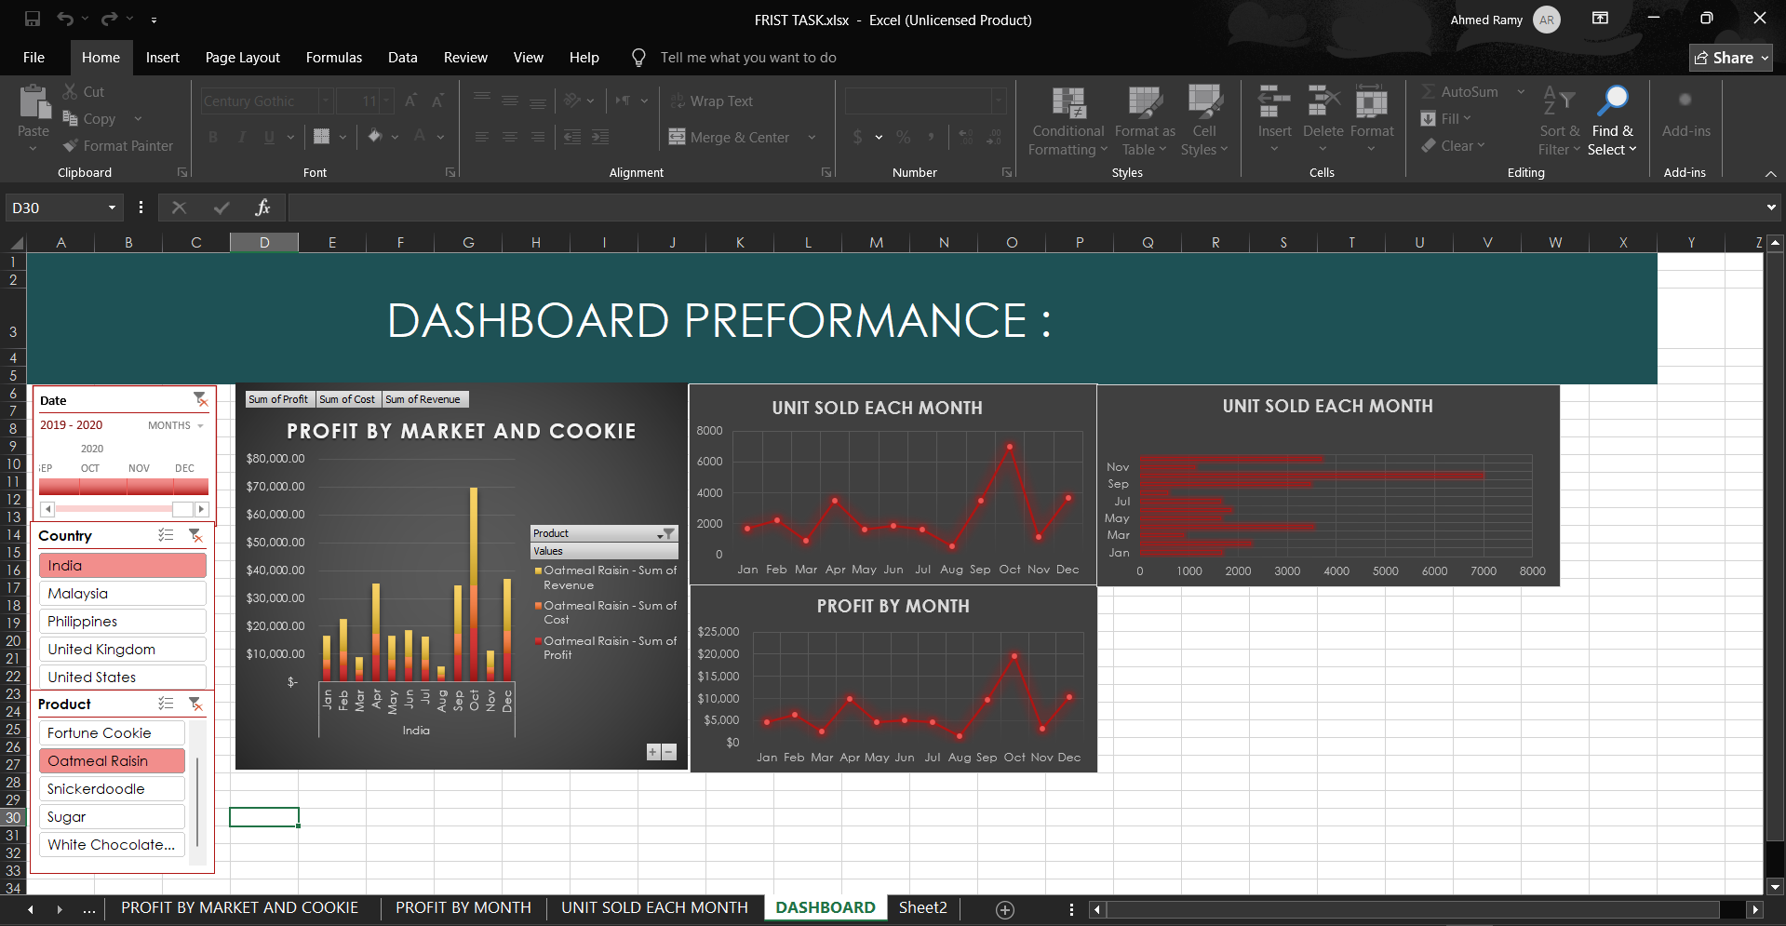

The Dashboard worksheet provides a visual summary of the project.

The dashboard is designed to help users understand business performance quickly without having to inspect the raw data.

Important KPIs include:

* Total Revenue
* Total Cost
* Total Profit
* Total Units Sold
* Monthly Profit
* Monthly Units Sold
* Market Performance
* Product Performance

The dashboard acts as the final presentation layer of the project.

---

### 5.6 Sheet2 – Business Questions / Calculations

This worksheet contains calculations and answers to important business questions.

Examples include:

* What is the total cost?
* What is the total average?
* What is the total revenue?
* What is the total number of units sold?
* What is the monthly performance?

This sheet provides a quick reference for the main numerical results.

---

## 6. Key Performance Indicators (KPIs)

The project focuses on several important KPIs.

### Total Revenue

Total revenue generated from all transactions.

The workbook contains a total revenue value of approximately:

*4,690,913*

---

### Total Cost

Total cost associated with all transactions.

The workbook contains a total cost of approximately:

*1,926,524.55*

---

### Total Units Sold

The total number of units sold across all transactions is approximately:

*1,125,824 units*

---

### Profit

Profit can be calculated using:

text
Profit = Revenue - Cost

Based on the overall revenue and cost figures:

text
Profit ≈ 4,690,913 - 1,926,524.55

Therefore:

*Profit ≈ 2,764,388.45*

---

## 7. Data Analysis Techniques Used

Several Excel techniques were used to analyze the dataset.

### PivotTables

PivotTables were used to summarize large amounts of transaction data.

They allow the project to analyze:

* Profit by month
* Units sold by month
* Profit by market
* Profit by product
* Revenue by market
* Cost by market

---

### Aggregation Functions

The project uses aggregation concepts such as:

* SUM
* AVERAGE
* COUNT
* SUMIF
* AVERAGEIF

These functions help calculate business KPIs.

Example:

excel
=SUM(E2:E701)

This calculates the total cost.

---

### Monthly Analysis

The Date column is used to group transactions by month.

This allows the project to identify:

* Best-performing months
* Weak-performing months
* Seasonal trends
* Changes in demand
* Changes in profitability

---

## 8. Business Questions

The project answers important business questions such as:

### Question 1

*What is the total revenue?*

Business Benefit:

Measures the overall sales generated by the business.

---

### Question 2

*What is the total cost?*

Business Benefit:

Helps management understand the total expenses required to generate sales.

---

### Question 3

*What is the total profit?*

Business Benefit:

Shows the overall financial performance of the business.

---

### Question 4

*How many units were sold?*

Business Benefit:

Measures total product demand.

---

### Question 5

*Which month generated the highest profit?*

Business Benefit:

Helps identify the strongest period for profitability.

---

### Question 6

*Which month had the highest number of units sold?*

Business Benefit:

Helps identify periods of high customer demand.

---

### Question 7

*How does profit vary between markets?*

Business Benefit:

Helps management identify the strongest geographical markets.

---

### Question 8

*Which products generate the most profit?*

Business Benefit:

Helps the company focus on its most profitable products.

---

## 9. Dashboard Purpose

The dashboard provides a high-level overview of business performance.

Instead of analyzing hundreds of rows manually, management can use the dashboard to quickly answer questions such as:

* How much revenue did we generate?
* How much did we spend?
* How much profit did we make?
* How many units did we sell?
* Which month performed best?
* Which market performed best?
* Which product generated the highest profit?

This makes the dashboard useful for *business intelligence and decision-making*.

---

## 10. Project Workflow

The project follows this workflow:

text
Raw Sales Data
↓
Data Organization
↓
Excel Calculations
↓
PivotTables
↓
Monthly Analysis
↓
Market & Product Analysis
↓
KPI Calculations
↓
Dashboard
↓
Business Insights

---

## 13. Conclusion

This project demonstrates how Microsoft Excel can be used to transform raw sales data into useful business information.

By analyzing revenue, cost, profit, units sold, products, markets, and monthly performance, the project provides a clear view of the company's overall performance.

The dashboard makes the analysis easier to understand and allows decision-makers to quickly identify trends, opportunities, and areas that require improvement.

Overall, the project demonstrates practical skills in:

*Data Cleaning → Data Analysis → PivotTables → KPI Calculation → Data Visualization → Business Intelligence*

